-- RANK TRANSFORMATION

M_RNK_TOP5

CREATE TABLE RNK_PRODUCT(

STOREID NUMBER PRIMARY KEY,

YEAR NUMBER(4),

Q1 NUMBER(9,2),

Q2 NUMBER(9,2),

Q3 NUMBER(9,2),

Q4 NUMBER(9,2));

INSERT INTO RNK_PRODUCT VALUES(1, 2016, 33, 22, 11, 23);

INSERT INTO RNK_PRODUCT VALUES(2, 2017, 323, 22, 11, 88);

INSERT INTO RNK_PRODUCT VALUES(3, 2016, 343, 22, 111, 73);

INSERT INTO RNK_PRODUCT VALUES(4, 2016, 123, 121, 17, 73);

INSERT INTO RNK_PRODUCT VALUES(5, 2016, 13, 22, 111, 73);

INSERT INTO RNK_PRODUCT VALUES(6, 2016, 43, 22, 111, 73);

INSERT INTO RNK_PRODUCT VALUES(7, 2013, 13, 22, 111, 73);

INSERT INTO RNK_PRODUCT VALUES(8, 2012, 1451, 121, 17, 73);

INSERT INTO RNK_PRODUCT VALUES(9, 2013, 1321, 22, 111, 73);

INSERT INTO RNK_PRODUCT VALUES(10, 2011, 411, 22, 11341, 73);

CREATE TABLE T_RNK_PRODUCT(

YEAR NUMBER(4),

SALES_MAX5 NUMBER(5));

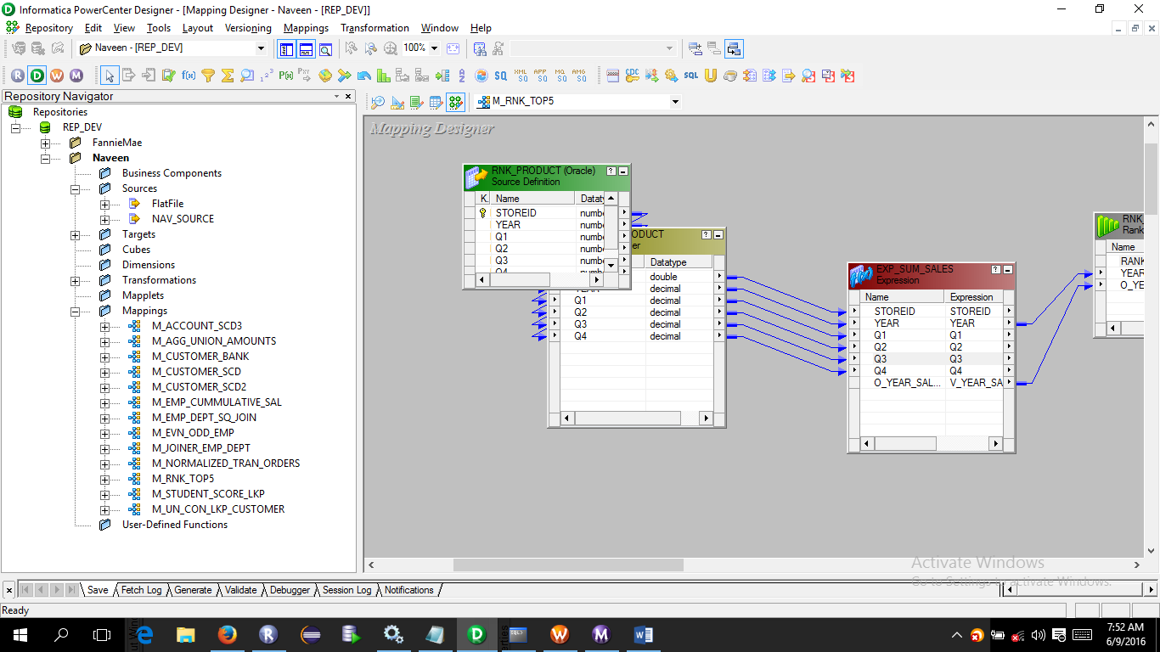

In Expression calculate the total sales of all quarters

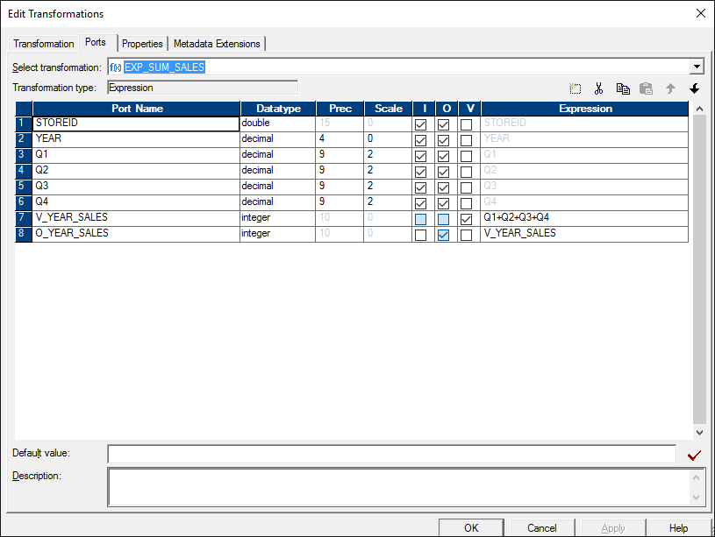

Create a rank transformation and drag which ever fields you want

